Heptagonal Prism
# Source: AI Source: Provided by: [Data Path: Persons Table -> ID Column: 1, Name_En Column: Motasem Essam] -> From: [ChatGPT] on [7/25/2026]
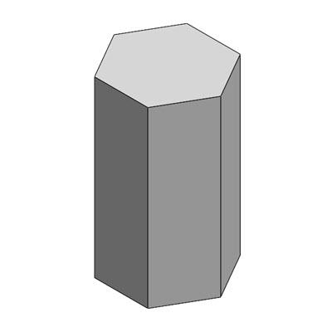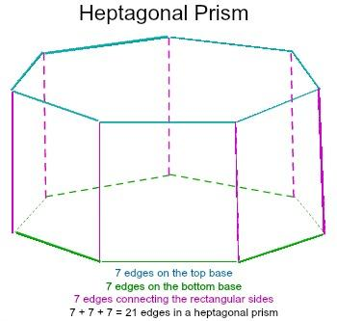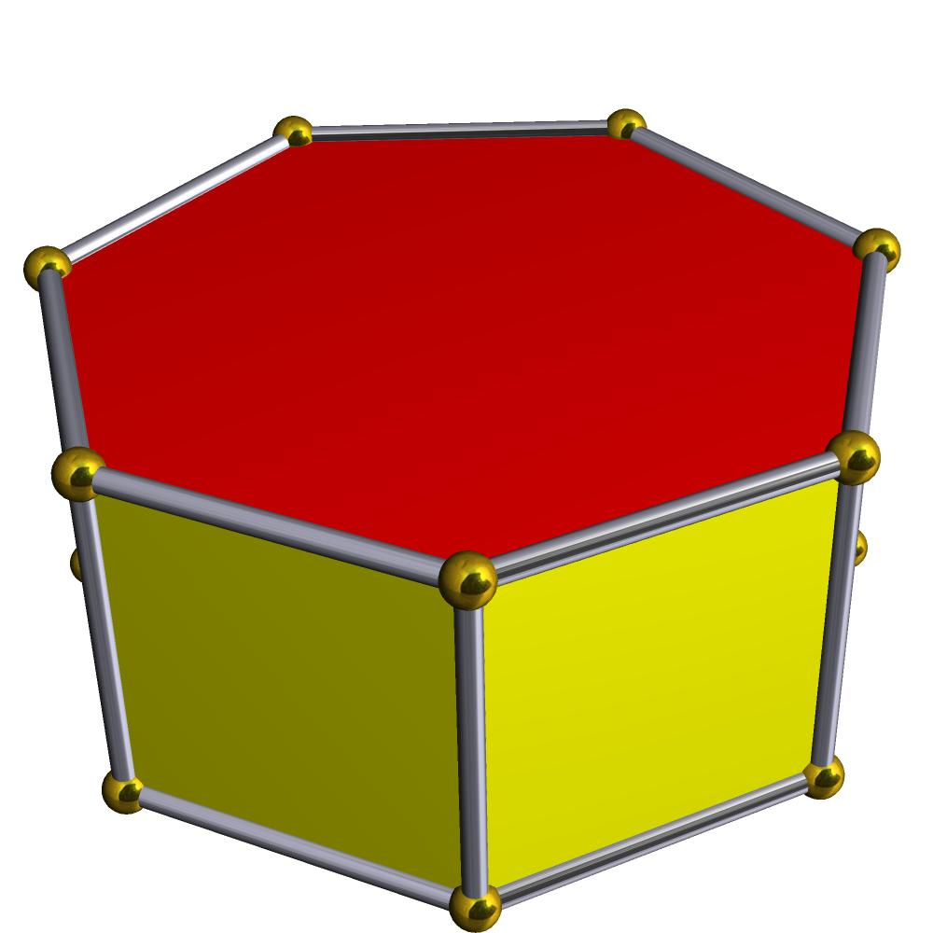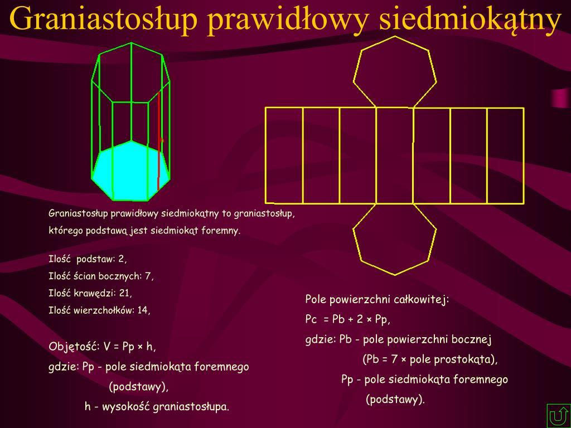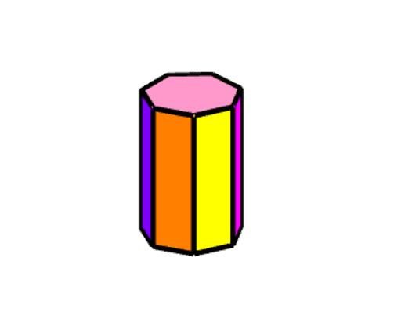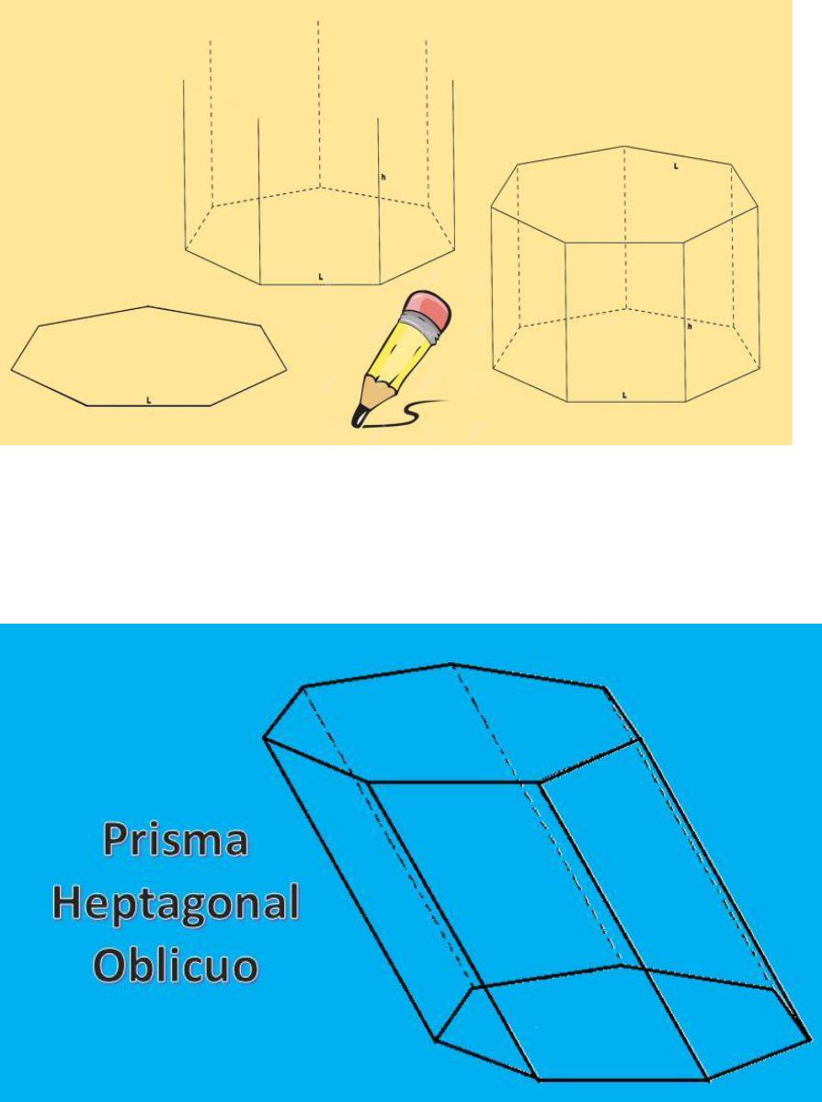

Definition
# Source: AI Source: Provided by: [Data Path: Persons Table -> ID Column: 1, Name_En Column: Motasem Essam] -> From: [ChatGPT] on [7/25/2026]
A heptagonal prism is a three-dimensional polyhedron with two congruent, parallel heptagonal bases connected by seven lateral faces.
Each heptagonal base has seven sides and seven vertices. The seven lateral faces connect corresponding edges of the two bases, forming a closed solid.
A right heptagonal prism has lateral edges perpendicular to the bases and rectangular lateral faces. An oblique heptagonal prism has inclined lateral edges and parallelogram lateral faces.

Simple Definition
# Source: AI Source: Provided by: [Data Path: Persons Table -> ID Column: 1, Name_En Column: Motasem Essam] -> From: [ChatGPT] on [7/25/2026]
A heptagonal prism is a solid shape with two identical heptagons at opposite ends and seven side faces.

Classification Tree
# Source: AI Source: Provided by: [Data Path: Persons Table -> ID Column: 1, Name_En Column: Motasem Essam] -> From: [ChatGPT] on [7/25/2026]
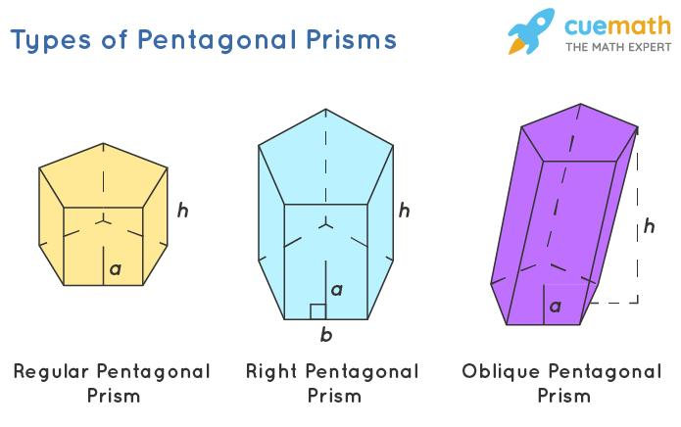
Right Heptagonal Prism
Lateral edges are perpendicular to the bases.
Oblique Heptagonal Prism
Lateral edges are inclined to the bases.
Regular-Base Prism
The bases are regular heptagons.
Irregular-Base Prism
The bases are irregular heptagons.
These classifications describe different properties. For example, a prism can be both right and regular-base. A regular heptagonal prism conventionally has regular heptagonal bases and perpendicular lateral edges.

Key Characteristics
# Source: AI Source: Provided by: [Data Path: Persons Table -> ID Column: 1, Name_En Column: Motasem Essam] -> From: [ChatGPT] on [7/25/2026]
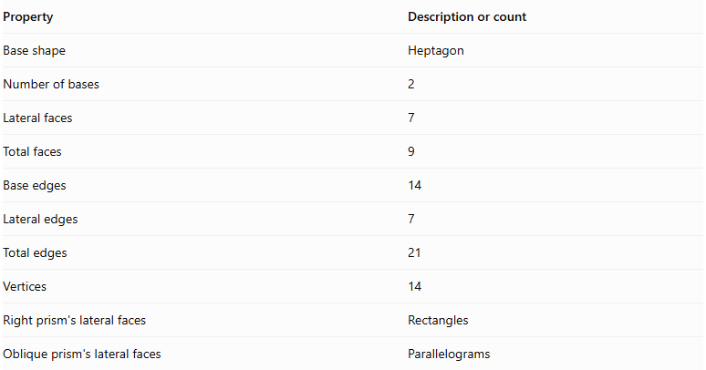
Property | Description or count
Base shape | Heptagon
Number of bases | 2
Lateral faces | 7
Total faces | 9
Base edges | 14
Lateral edges | 7
Total edges | 21
Vertices | 14
Right prism's lateral faces | Rectangles
Oblique prism's lateral faces | Parallelograms

Geometric Representation
# Source: AI Source: Provided by: [Data Path: Persons Table -> ID Column: 1, Name_En Column: Motasem Essam] -> From: [ChatGPT] on [7/25/2026]
The main components of a heptagonal prism are:
- Heptagonal bases: The two congruent, parallel heptagons.
- Lateral faces: The seven faces connecting the bases.
- Base edges: The fourteen edges around the two heptagonal bases.
- Lateral edges: The seven edges joining corresponding vertices of the bases.
- Vertices: The fourteen corner points of the solid.
- Height: The perpendicular distance between the two base planes.

Mathematical Representations and Formulas
# Source: AI Source: Provided by: [Data Path: Persons Table -> ID Column: 1, Name_En Column: Motasem Essam] -> From: [ChatGPT] on [7/25/2026]
Let:
- $B$ = Area of one heptagonal base.
- $P$ = Perimeter of one base.
- $h$ = Perpendicular height of the prism.
- $a$ = Side length of a regular heptagonal base.
- $r$ = Apothem of a regular heptagonal base.

A. Number of Faces, Edges, and Vertices
# Source: AI Source: Provided by: [Data Path: Persons Table -> ID Column: 1, Name_En Column: Motasem Essam] -> From: [ChatGPT] on [7/25/2026]
For a prism with an $n$-sided polygon as its base:
$$F=n+2$$
$$E=3n$$
$$V=2n$$
For a heptagonal prism, $n=7$:
$$F=7+2=\boxed{9}$$
$$E=3(7)=\boxed{21}$$
$$V=2(7)=\boxed{14}$$

B. Area of a Regular Heptagonal Base
# Source: AI Source: Provided by: [Data Path: Persons Table -> ID Column: 1, Name_En Column: Motasem Essam] -> From: [ChatGPT] on [7/25/2026]
For a regular heptagon with side length $a$:
$$B=\frac{7a^{2}}{4tan(π/7)}$$
Its perimeter is:
$$P=7a$$
Alternatively, using the apothem:
$$B=\frac{1}{2}Pr$$
For a regular heptagon, the apothem is:
$$r=\frac{a}{2tan(π/7)}$$

C. Volume
# Source: AI Source: Provided by: [Data Path: Persons Table -> ID Column: 1, Name_En Column: Motasem Essam] -> From: [ChatGPT] on [7/25/2026]
The volume of any prism is its base area multiplied by its perpendicular height:
$$\boxed{V=Bh}$$
For a regular heptagonal prism:
$$\boxed{V=\frac{7a^{2}h}{4tan(π/7)}}$$

D. Lateral Surface Area
# Source: AI Source: Provided by: [Data Path: Persons Table -> ID Column: 1, Name_En Column: Motasem Essam] -> From: [ChatGPT] on [7/25/2026]
For a right heptagonal prism:
$$\boxed{LSA=Ph}$$
Since for a regular heptagon:
$$\boxed{LSA=7ah}$$
For an oblique prism, add the actual areas of its seven lateral parallelograms.

E. Total Surface Area
# Source: AI Source: Provided by: [Data Path: Persons Table -> ID Column: 1, Name_En Column: Motasem Essam] -> From: [ChatGPT] on [7/25/2026]
The total surface area includes the seven lateral faces and both bases:
$$\boxed{TSA=LSA+2B}$$
For a regular right heptagonal prism:
$$\boxed{TSA=7ah+\frac{7a^{2}}{2tan(π/7)}}$$

Worked Examples

Example 1: Counting Faces, Edges, and Vertices
# Source: AI Source: Provided by: [Data Path: Persons Table -> ID Column: 1, Name_En Column: Motasem Essam] -> From: [ChatGPT] on [7/25/2026]
Problem: Find the number of faces, edges, and vertices of a heptagonal prism.
Solution:
The base is a heptagon, so $n=7$.
$$F=7+2=9$$
$$E=3(7)=21$$
$$V=2(7)=14$$
Answer: The prism has 9 faces, 21 edges, and 14 vertices.

Example 2: Calculating the Volume
# Source: AI Source: Provided by: [Data Path: Persons Table -> ID Column: 1, Name_En Column: Motasem Essam] -> From: [ChatGPT] on [7/25/2026]
Problem: A heptagonal prism has a base area of $100{ cm}^{2}$ and a perpendicular height of $12 cm$. Find its volume.
Solution:
$$V=Bh$$
$$V=100×12$$
$$\boxed{V=1200{ cm}^{3}}$$

Example 3: Calculating the Area of a Regular Heptagonal Base
# Source: AI Source: Provided by: [Data Path: Persons Table -> ID Column: 1, Name_En Column: Motasem Essam] -> From: [ChatGPT] on [7/25/2026]
Problem: A regular heptagonal prism has a base side length of $4 cm$. Find the area of one base.
Solution:
$$B=\frac{7a^{2}}{4tan(π/7)}$$
Substitute $a=4$:
$$B=\frac{7(4)^{2}}{4tan(π/7)}$$
$$B=\frac{112}{4tan(π/7)}$$
$$\boxed{B≈58.14{ cm}^{2}}$$

Example 4: Calculating Total Surface Area
# Source: AI Source: Provided by: [Data Path: Persons Table -> ID Column: 1, Name_En Column: Motasem Essam] -> From: [ChatGPT] on [7/25/2026]
Problem: A regular right heptagonal prism has a side length of $5 cm$ and a height of $10 cm$. Find its total surface area.
Step 1: Calculate the base perimeter.
$$P=7(5)=35 cm$$
Step 2: Calculate the lateral surface area.
$$LSA=Ph=35(10)=350{ cm}^{2}$$
Step 3: Calculate the area of one base.
$$B=\frac{7(5)^{2}}{4tan(π/7)}$$
$$B≈90.84{ cm}^{2}$$
Step 4: Calculate the total surface area.
$$TSA=LSA+2B$$
$$TSA=350+2(90.84)$$
$$\boxed{TSA≈531.68{ cm}^{2}}$$

Example 5: Verifying Euler's Formula
# Source: AI Source: Provided by: [Data Path: Persons Table -> ID Column: 1, Name_En Column: Motasem Essam] -> From: [ChatGPT] on [7/25/2026]
Euler's formula for a convex polyhedron is:
$$V-E+F=2$$
For a heptagonal prism:
$$14-21+9=2$$
Therefore, the heptagonal prism satisfies Euler's formula.

Comparison with Related Prisms
# Source: AI Source: Provided by: [Data Path: Persons Table -> ID Column: 1, Name_En Column: Motasem Essam] -> From: [ChatGPT] on [7/25/2026]
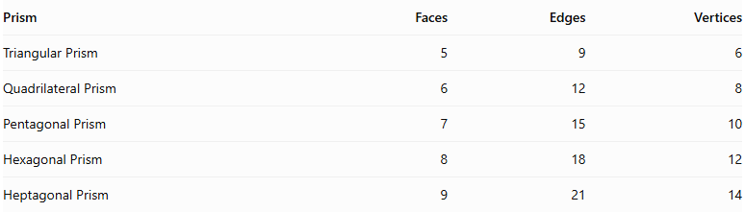
Prism | Faces | Edges | Vertices
Triangular Prism | 5 | 9 | 6
Quadrilateral Prism | 6 | 12 | 8
Pentagonal Prism | 7 | 15 | 10
Hexagonal Prism | 8 | 18 | 12
Heptagonal Prism | 9 | 21 | 14
As the number of sides of the polygonal base increases by one, the prism gains one lateral face, three edges, and two vertices.

Constructing Heptagonal Prism in Solid Geometry

Instruments Used
# Source: AI Source: Provided by: [Data Path: Persons Table -> ID Column: 1, Name_En Column: Motasem Essam] -> From: [ChatGPT] on [7/25/2026]
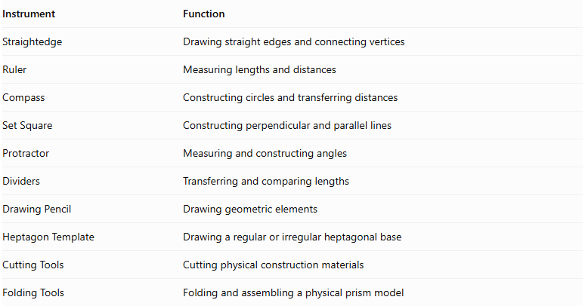
Instrument | Function
Straightedge | Drawing straight edges and connecting vertices
Ruler | Measuring lengths and distances
Compass | Constructing circles and transferring distances
Set Square | Constructing perpendicular and parallel lines
Protractor | Measuring and constructing angles
Dividers | Transferring and comparing lengths
Drawing Pencil | Drawing geometric elements
Heptagon Template | Drawing a regular or irregular heptagonal base
Cutting Tools | Cutting physical construction materials
Folding Tools | Folding and assembling a physical prism model

Construction Procedures

Right Heptagonal Prism Construction
# Source: AI Source: Provided by: [Data Path: Persons Table -> ID Column: 1, Name_En Column: Motasem Essam] -> From: [ChatGPT] on [7/25/2026]
- Construct a heptagonal base using geometric instruments.
- Determine the required perpendicular height.
- Construct a second heptagon congruent to the first.
- Position the second base parallel to the first.
- Ensure that corresponding vertices are aligned along perpendicular lateral edges.
- Connect the corresponding vertices of both bases.
- Complete the seven rectangular lateral faces.
- Identify the visible and hidden edges to complete the geometric representation.

Oblique Heptagonal Prism Construction
# Source: AI Source: Provided by: [Data Path: Persons Table -> ID Column: 1, Name_En Column: Motasem Essam] -> From: [ChatGPT] on [7/25/2026]
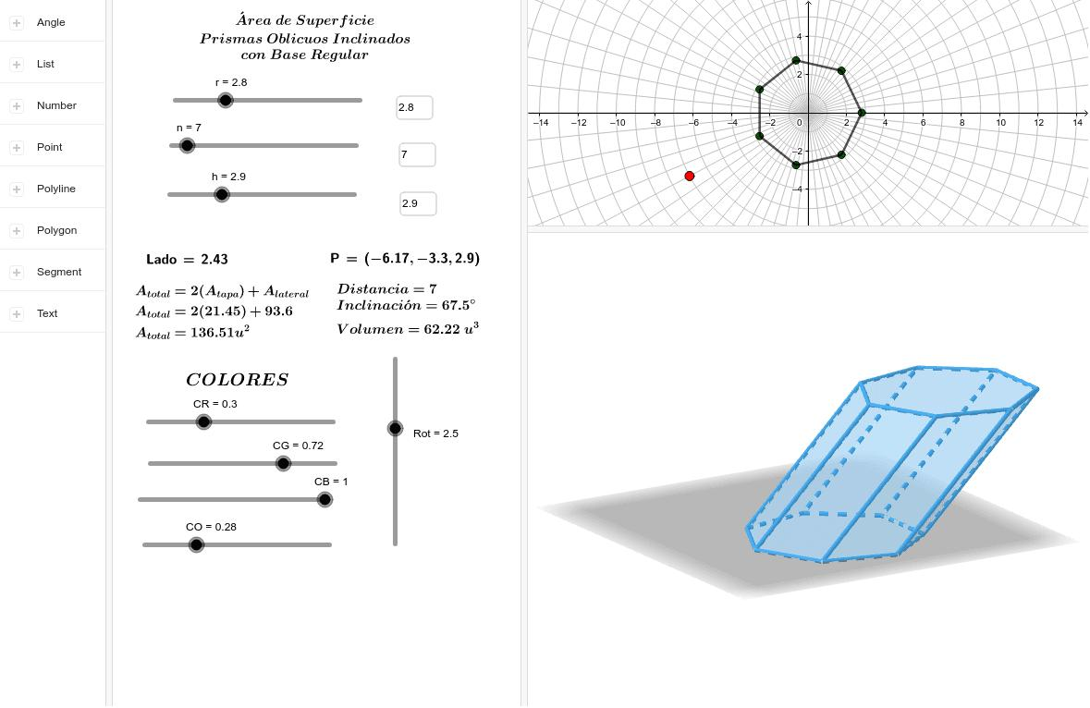
- Construct the first heptagonal base.
- Determine the required direction and inclination of the lateral edges.
- Construct a second congruent heptagon in a parallel plane.
- Displace the second base in the selected oblique direction.
- Connect corresponding vertices using parallel lateral edges of equal length.
- Complete the seven parallelogram lateral faces.
- Identify the visible and hidden edges.

Net-Based Construction
# Source: AI Source: Provided by: [Data Path: Persons Table -> ID Column: 1, Name_En Column: Motasem Essam] -> From: [ChatGPT] on [7/25/2026]
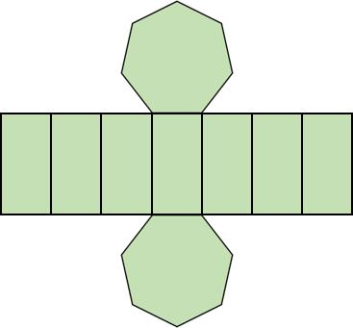
- Construct two congruent heptagonal bases.
- Draw seven connected lateral faces.
- Arrange the lateral faces in a strip.
- Add the two heptagonal bases in suitable positions.
- Add joining tabs if required for physical assembly.
- Cut out the net.
- Fold the lateral faces and attach the two bases.

Extrusion-Based Construction
# Source: AI Source: Provided by: [Data Path: Persons Table -> ID Column: 1, Name_En Column: Motasem Essam] -> From: [ChatGPT] on [7/25/2026]
- Construct a heptagonal base.
- Establish a straight translation direction.
- Transfer the heptagonal boundary along that direction.
- Construct the translated congruent heptagon.
- Connect corresponding vertices.
- Complete the lateral faces to form the prism.

Applications of Heptagonal Prisms
# Source: AI Source: Provided by: [Data Path: Persons Table -> ID Column: 1, Name_En Column: Motasem Essam] -> From: [ChatGPT] on [7/25/2026]
Heptagonal prisms can appear in several practical and mathematical settings:
- Architecture: Heptagonal columns and structural components.
- Engineering: Seven-sided structural components and geometric models.
- Product Design: Objects with heptagonal cross-sections.
- Education: Demonstrating faces, edges, vertices, surface area, and volume.
- Computer Graphics: Representing three-dimensional polygonal objects.

Key Points
# Source: AI Source: Provided by: [Data Path: Persons Table -> ID Column: 1, Name_En Column: Motasem Essam] -> From: [ChatGPT] on [7/25/2026]
- A heptagonal prism has two congruent, parallel heptagonal bases.
- It has seven lateral faces and nine faces in total.
- It has 21 edges and 14 vertices.
- Its volume is $V=Bh$.
- For a right prism, its lateral surface area is $LSA=Ph$.
- Its total surface area is $TSA=LSA+2B$.
- The area of a regular heptagonal base is $B=\frac{7a^{2}}{4tan(π/7)}$.
- It satisfies Euler's formula $V-E+F=2$.

Conclusion
# Source: AI Source: Provided by: [Data Path: Persons Table -> ID Column: 1, Name_En Column: Motasem Essam] -> From: [ChatGPT] on [7/25/2026]
A heptagonal prism is a polyhedron with two congruent, parallel heptagonal bases joined by seven lateral faces. It has nine faces, twenty-one edges, and fourteen vertices, making it a useful example of a prism with a seven-sided polygonal base.
Its volume is calculated by multiplying the base area by the perpendicular height, while its total surface area is the sum of the lateral surface area and the areas of both bases. For a regular heptagonal prism, the base area can be calculated directly from its side length.
Understanding the heptagonal prism extends the general rules for polygonal prisms and helps explain how the number of sides of a base determines a solid's faces, edges, and vertices.

